

**NETWORKING & SYSTEM ADMINISTRATION LAB**

**Experiment No.: 7**

**Aim**

Familiarization with linux commands.

**Procedure**

*1.To we want create new user or new group*

*->Sudo useradd username*

*->sudo useradd salu*

**Output Screenshot**

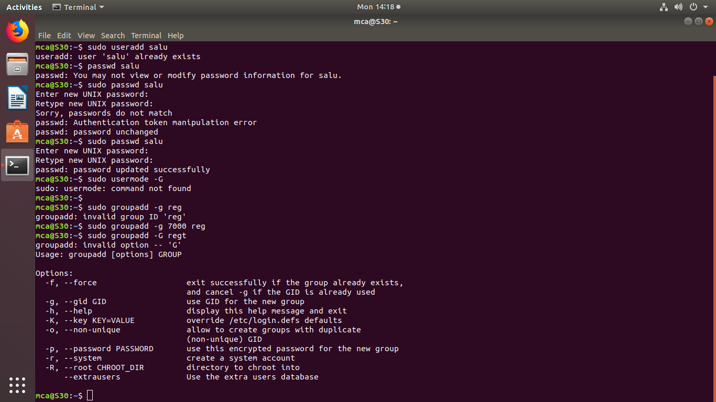

2.set password

- >Sudo passwd username

**Output** 

3.Group add/create

->sudo groupadd –g 7000 “Groupname”

-> sudo groupadd –G 7000 reg

**output**



**4.Add new user**

**-> sudo usermod –G gruopname username**

**->sudo usermod –G reg salu**

**Output**

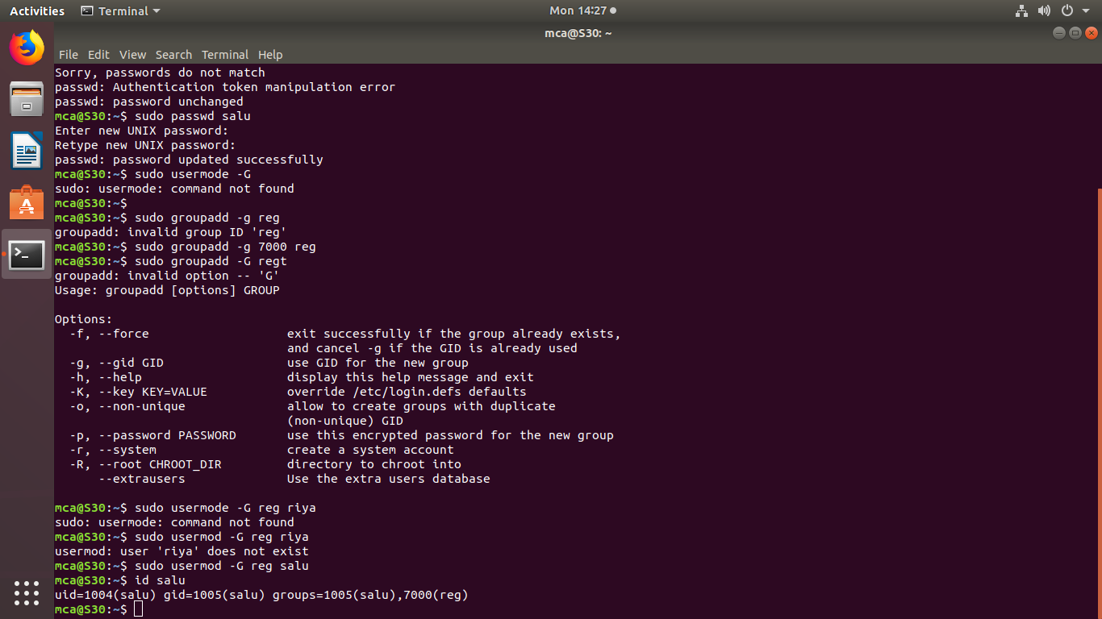

**5]id username**

**->user existing or not can be viewed.**

**->id salu**



**6]compgen –g**

**->View already existing group**

**Output**

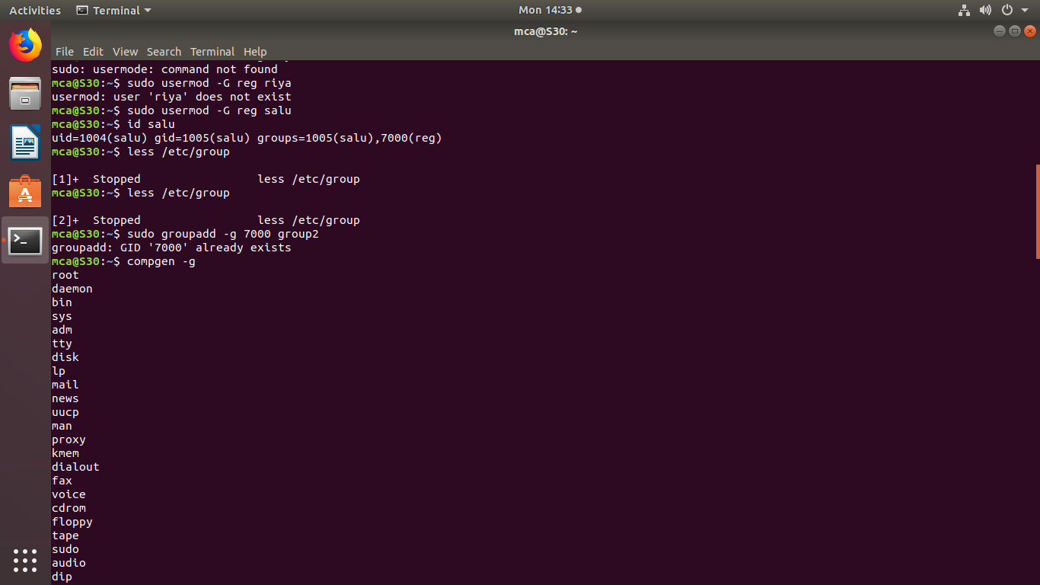

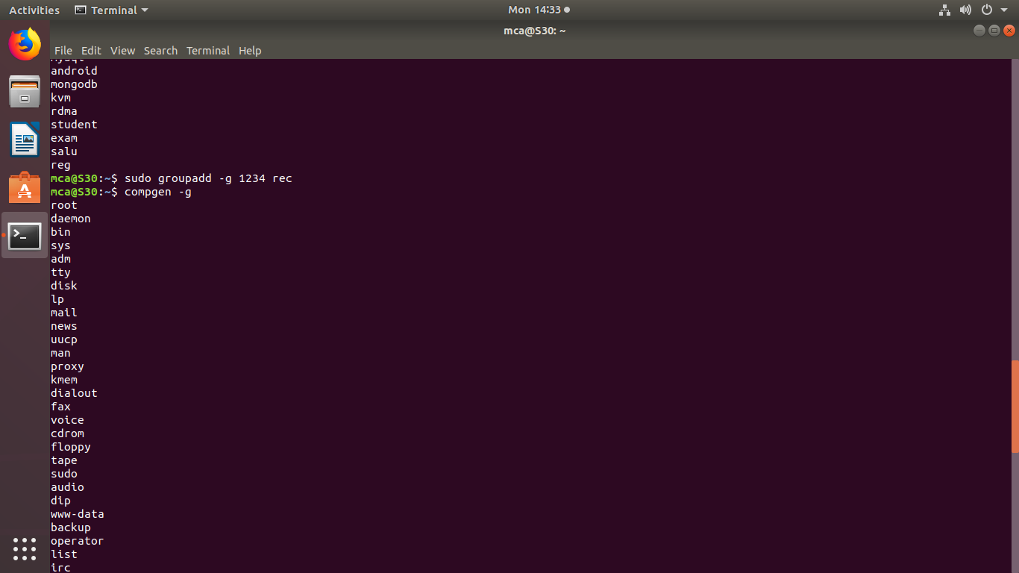

**7]sudo useradd username**

**->Add new username**

**->sudo useradd user**

**Output**

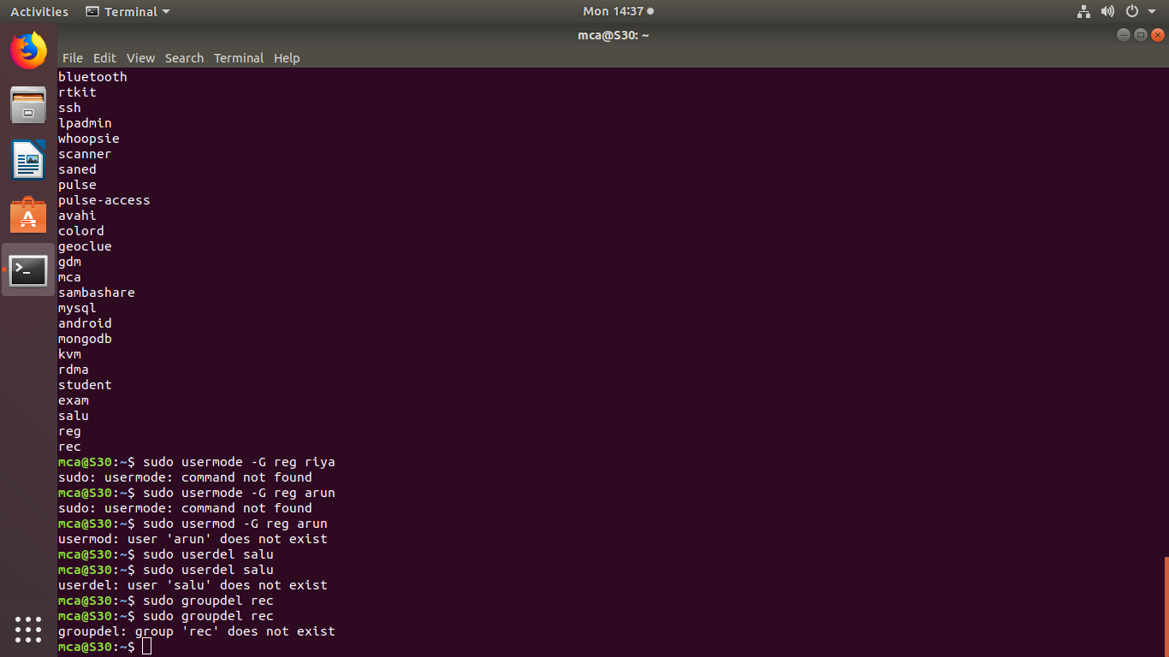

8]Delete user

->sudo userdel username

->sudo userdel salu



9]view particular group

->compgen –g groupname

10]Delete group

->sudo userdel rec



11]Directory permission of the file

Chmod

->rws-read write execute

->chmod +rws filename

->chmod –ws filename

->chmod –rws filename

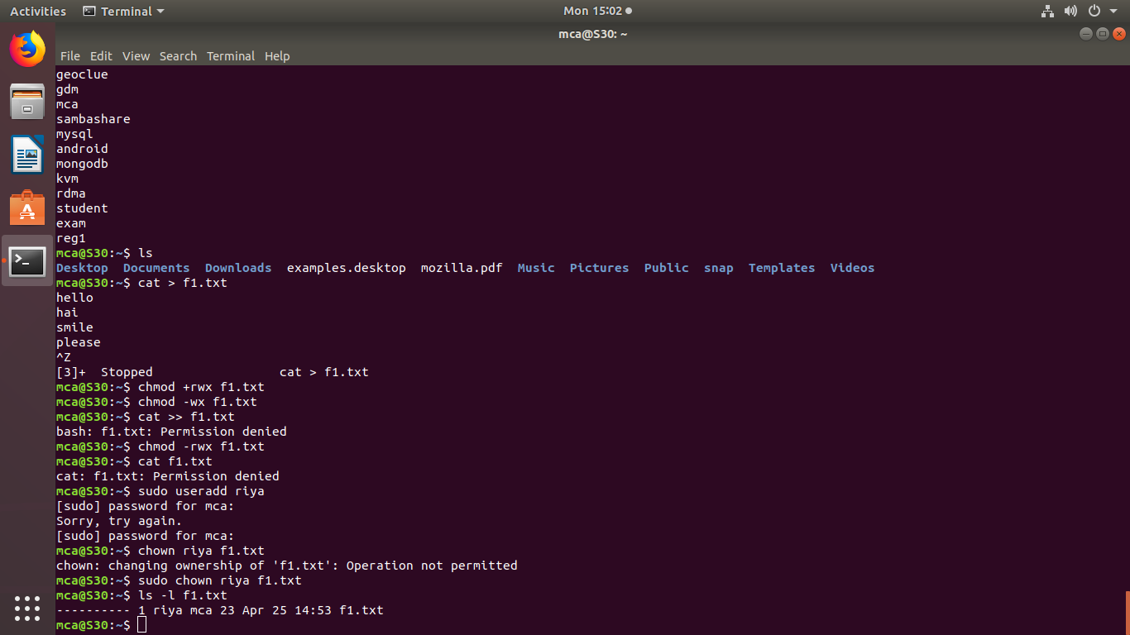

12]change ownership

->sudo chown newusername filename

->sudo chown riya f1.txt

output

13]useradd

->sudo useradd username

->sudo useradd riya

output

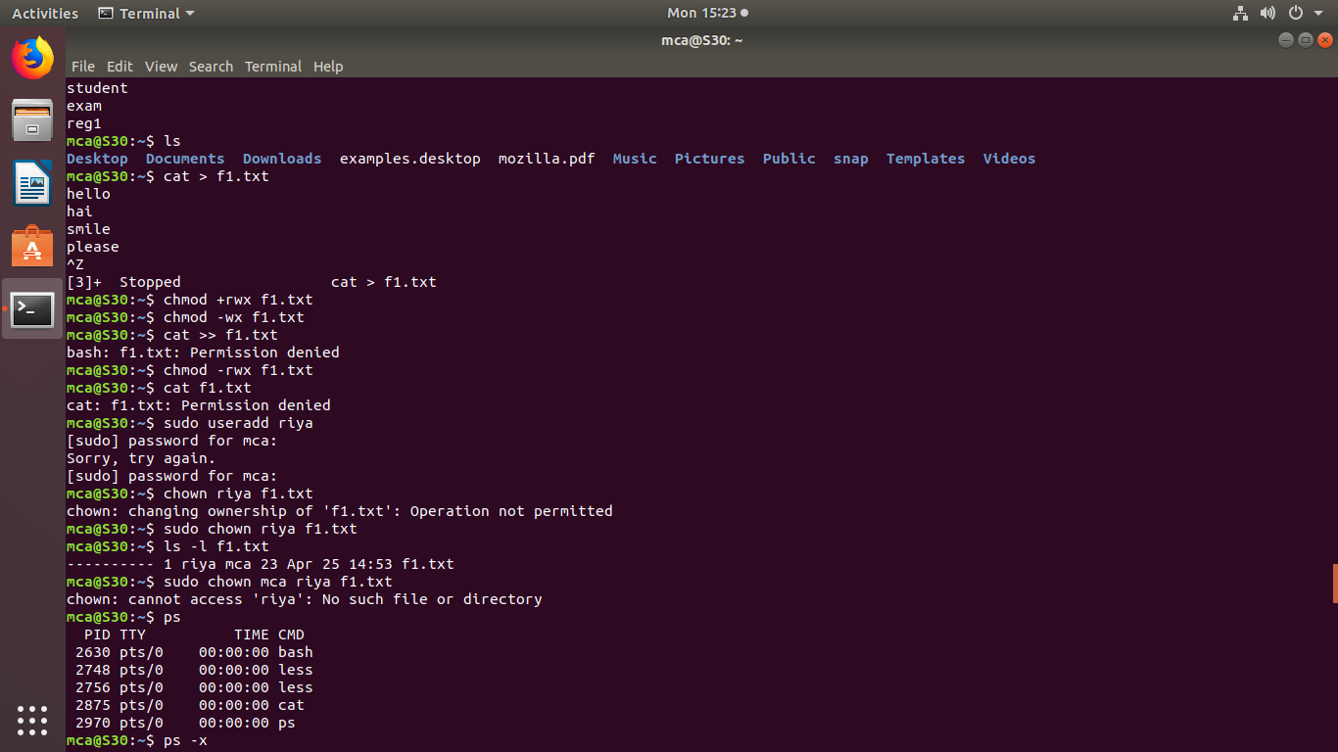

14]New ownership can be viewed

->Ls –l filename

->Ls –l f1.txt

output